Module V PHOTONICS
Photonics deals with the production, control and detection of photons. Its applications are in communication, data processing, transportation, medicine, lighting, biotechnology, etc.
Light Emitting Diode (LED)
- LED is a heavily doped pn junction. When current flows across a diode negative electrons and positive holes move in opposite directions
- The holes exist at a lower energy level than the free electrons.
- Therefore when a free electrons recombine with hole, it losses energy.
- This energy is emitted in a form of a photon, which causes light.
- The color of the light is determined by the energy gap between that of hole and electron.
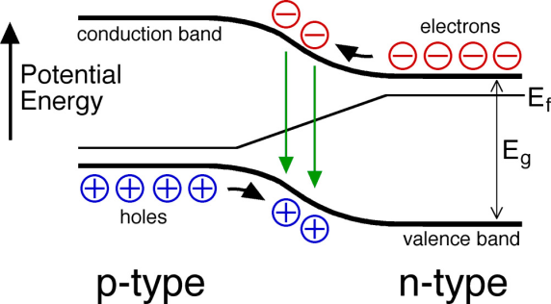
λ=$\frac{hc}{E_{g}}$ ; where E_{g} is the band gap energy
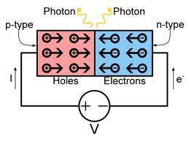
The colour of light emitted depends on band gap energy E_{g}. Intensity of light emitted increases with increase of forward current. Generally LED are monochromatic. White light is produced from LEDs by two methods;
- RGB (Red Green Blue) Mixing: Mixing of light from different LEDs
- Phosphor conversion: A phosphor is used to absorb light in blue or near ultraviolet region and to emit white light

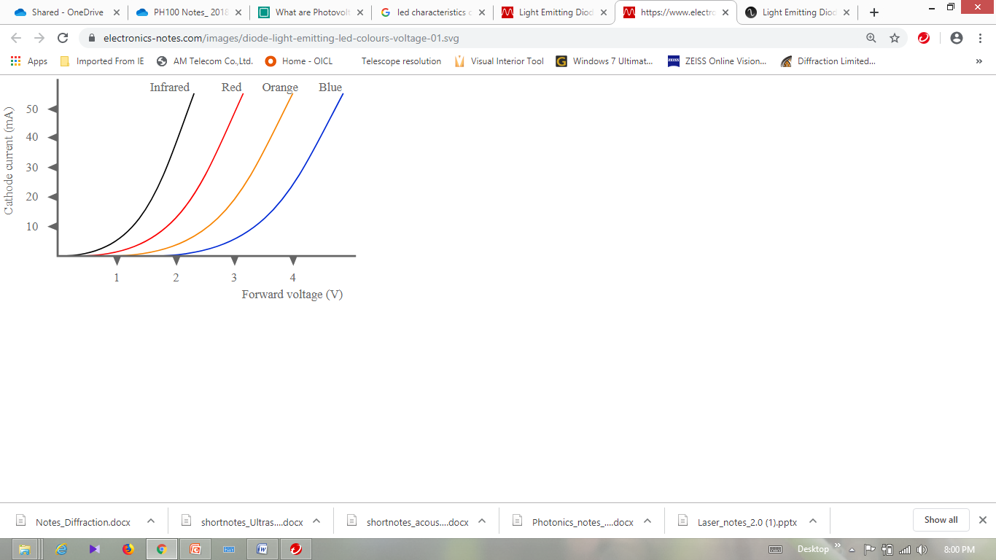
V-I Characteristics of LED:
Advantages:
- Long life, if used in a suitable environment. Saving future maintenance cost.
- Very high efficiency & lower power consumption compared to incandescent lights.
- Light weight and miniature size.
- Lower heat output, conventional incandescent lights waste about 90% of their power on heat output.
- Typically lower infra-red and ultraviolet output.
- Faster switching time and less likely to be damaged by on-off cycles.
- They are usually more rugged. There is normally no glass to break and no filament to damage via vibration.
Disadvantages:
- High initial price.
- May fail prematurely in high temperature conditions.
- Small increase in voltage can cause permanent damage to LED
- Light output and colour quality can degrade over time period
Applications:
Light-emitting diodes are used in applications as diverse as aviation lighting, automotive headlamps, advertising, general lighting, traffic signals, camera flashes, lighted wallpaper and medical devices.
PHOTODETECTOR
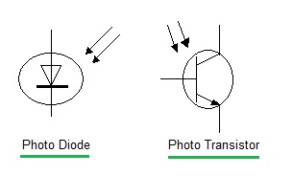
Photodetector is a semiconductor device that converts light into current. The current is generated when photons are absorbed in the detector. Main properties of photodetector are;
- Sensitive in a spectral region (range of optical wavelengths)
- Support a range of optical input power.
- Support only a range of frequencies.
- Low noise
- Dark current; the small amount of current that is present when no light is present.
Photovoltaic Effect:
It is the phenomenon of production of an emf across junction of two dissimilar materials by incidence of light
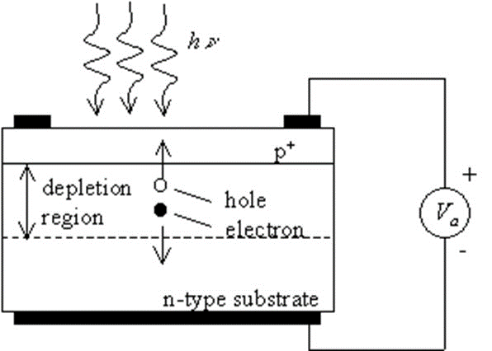
Junction Photodiode
It is a pn junction, with a thin p-layer on thicker n-type material layer. Light enters the junction through p-layer. When light is incident on either n or p type, it gets absorbed and an electrons are released from valance band and it goes into conduction band. This creates holes in valance band. So a large number of electron-hole pairs are created which results in current called photocurrent.
Applications:
Barcode scanners, security systems, optical communication
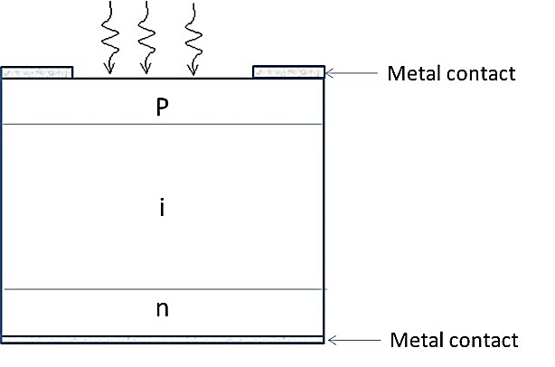
PIN Photodiode
In PIN photodiode, a wide intrinsic semiconductor is placed between heavily doped p type and n-type regions. The depletion region of a PIN structure extends across the intrinsic region, deep into the device. This wider depletion width enables electron-hole pair generation deep within the device. This increases the efficiency of the diode.
The advantage of using a PIN photodiode over junction photodiode is the better long wavelength response and increased quantum efficiency.
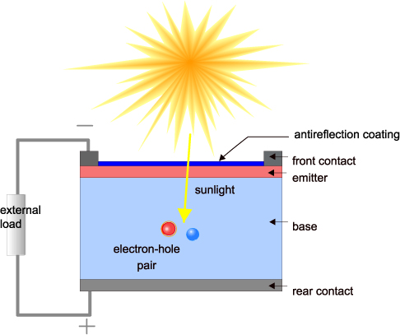
SOLAR CELL
- Solar cell is a device which converts sunlight into electricity.
- It consists of an array of large area junction photodiodes
- Sunlight is absorbed at the p-n interface and electron-hole pairs are produced. The electric field at the junction pulls electrons towards n-region and holes towards p-type region. As a result a current flows from p-terminal to n-terminal.
- In a solar panel, array of photodiodes connected in series to increase output voltage then in parallel to increase output current.

Characteristics of Solar Cell
Experimental setup to study I-V characteristics of solar cell is shown in figure. Typical I-V characteristics are shown in second figure.
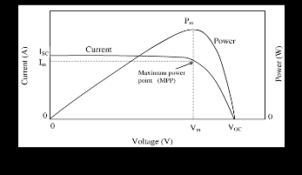
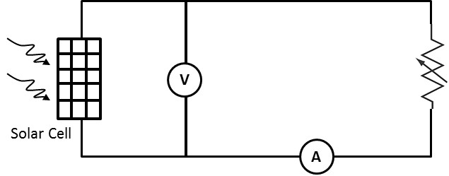

Short circuit current (I_{sc}) is the current through solar cell when the voltage across is zero. V_{oc} is the open circuit voltage across solar cell when the current is zero.
Maximum Power Point (MPP) is the condition under which solar cell generates its maximum power output( P_{max} =I_{max} x V_{max})
Fill Factor - FF $=\frac{\text{V}\text{max }\text{x I}\text{max}}{\text{V}\text{oc }\text{xI}sc}$
Conversion Efficiency, η$=FF x \frac{\text{V}\text{oc }\text{x I}sc}{EA}$
Where E-input irradiance and A-Area of solar Cell
Applications
- In artificial satellites
- As electrical power generator in solar street lighting systems, inverters etc.
Optical Fiber
- Optical fibers are circular dielectric wave-guides that can transport optical energy and information.
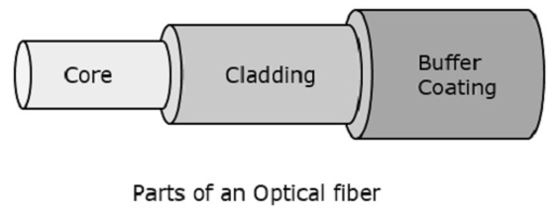
- They have a central core surrounded by a concentric cladding with slightly lower (by ≈ 1%) refractive index.
- Optical fibers are made of glass and plastic. Plastic fibers are more flexible. But due to higher attenuation/power loss, plastic fibers are not used for long haul transmission.
- Optical fiber transmits light along its axis, by the process of total internal reflection.

Types of optical fiber
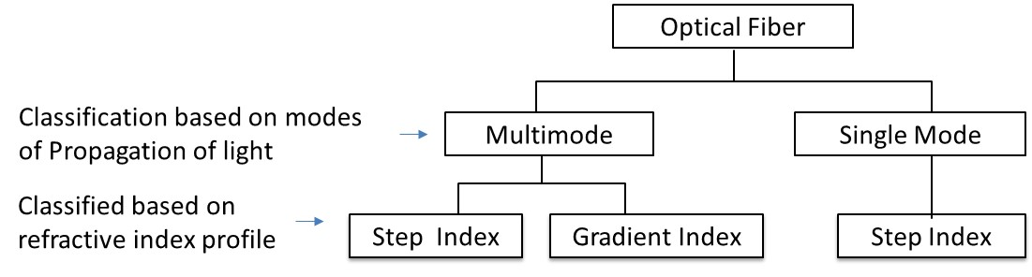
1. Multimode Step index fiber
- Core refractive index is constant.
- Refractive index reduces abruptly at core-cladding boundary
- Supports multiple modes of propagation of light
2. Multimode graded index fiber
- Refractive index of core gradually reduces as the distance increases from the centre
- Supports multiple modes of propagation of light
3. Single mode Step index fiber
- Core refractive index is constant.
- Refractive index reduces abruptly at core-cladding boundary
- Supports only single mode of propagation of light

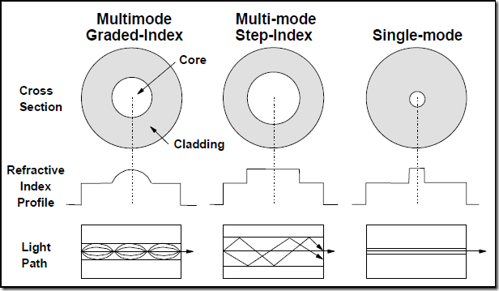
n₁
n₂ n₂

n₁
n₂ n₂

n₁
n₂ n₂

Multimode Graded Index Multimode Step Index Singlemode Step Index

Advantages of Optical Fiber
- Low transmission loss. Typical attenuation of a Single mode fiber is 0.15dB/km. This reduces the requirement for repeaters (or amplifiers)
- Optical fibers used in communication are made of silica glass and have a diameter of 100to 250μm only. This results in low volume and weight making it easy to handle
- Immune to electromagnetic interference hence eliminates cross talk.
- Can be used in hazardous environments including high voltage environments.
- Made of silica glass, which is abundant in nature and very cheap
- High Bandwidth Over Long Distances ( presently available networks support upto 100GbPs)
- Non-flammable: Because no electricity is passed through optical fibers, there is no fire hazard.
Numerical aperture (NA) of Fiber
Numerical Aperture (NA) of a fiber is a measure of light gathering capacity of fiber. NA is the measure of angle over which light is accepted in the fiber. Light entering fiber within the acceptance angle will transmit through it.
NA = sin α_{m} where α_{m} is the acceptance angle
Numerical Aperture (NA) of Step Index Fiber
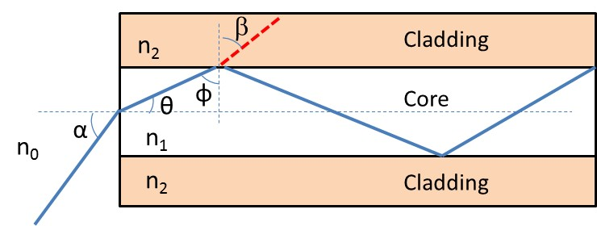
Consider a step index fiber with core of refractive index n1 and cladding of refractive index n2. From figure;
i) α is the angle that incident ray makes with axis of the fiber
ii) θ is the angle that incident ray makes with axis of the fiber, inside the fiber and
i) φ is the angle that ray makes at core –cladding boundary.
Using Snell’s law at air - core interface
n_{o} sin α = n ₁sinθ
θ = 90 – φ
n_{o} sin α = n₁ cosφ ---------------------------------------------(1) { Sin(90- θ) = Cos φ }
Using Snell’s law at core - cladding interface
n₁ sinφ = n₂ Ssinβ ----------------------------------------------(2)
Light starts reflecting back to the core for angles φ≥φ_{c} ,critical angle.
when φ= φ_{c}, we have β =90 , α= α_{m} and θ = θ_{m}
From eqn (2), n₁ sinφ _{c}= n₂
$\text{s}\text{in}\text{ c}=\frac{\text{n}\text{2}}{\text{n}\text{1}}$ ---------------------------(3)
$\text{c}\text{os}\text{c}=\sqrt{1-sin\text{2}\text{c}} =\frac{\sqrt{\text{n}\text{1}\text{2}-\text{n}\text{2}\text{2}}}{\text{n}\text{1}}$----------------(4)
When φ= φ_{c} we have α=α_{m}, maximum angle of incidence (acceptance angle).Using eqn(4) in eqn(1)
sin α_{m}= n₁ cosφ_{c}
n_{o} sin α_{m}= n₁ $\frac{\sqrt{\text{n}\text{1}\text{2}-\text{n}\text{2}\text{2}}}{\text{n}\text{1}}$
NA = sin α_{m} =$\frac{\sqrt{\text{n}\text{1}\text{2}-\text{n}\text{2}\text{2}}}{\text{n}\text{0}}$
For Air n_{o}=1

NA = Sin α_{m}= $\sqrt{\text{n}\text{1}\text{2}-\text{n}\text{2}\text{2}}$
OPTICAL FIBER COMMUNICATION
Communicatioan system which carries information through a guided optical fiber is called fiber optic communication system. The main parts of an optical fiber communication system are Encoder, Optical Transmitter, Optical fiber, Optical amplifier,Optical reciever and decoder.
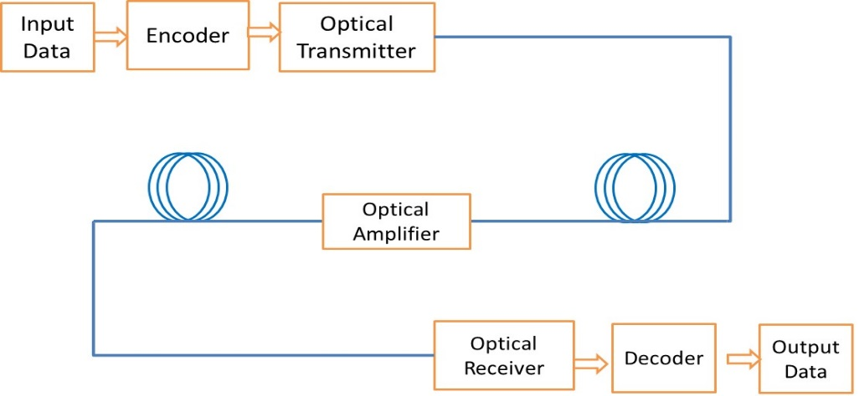
User input tis the data , which the encoder converts into a coded signal. Optical transmitter usually consists of a laser or an LED. Light is transmitted through optical fiber. Optical amplifier is used to amplify the signal such that it can travel longer distance. Opticalreciver is a photodetector which converts the optical signal into electrical signal. Decoder removes the coding and data is given to the user.
Fiber Optic Sensors
An optical fiber sensor, in general consists of a light source, photodetector, and optical fiber to carry light to the material under test and back to detector.
1. Intensity Modulated Sensor
Intensity Modulated sensors measure change in intensity, thereby measuring the cause of the change.
Input light is transmitted to the measuring end through a fiber. Light reflected from diaphragm is transmitted to the Photodetector. Diaphragm will change shape and move based on change in pressure. This will result in variation in intensity of reflected light. Hence the variation in pressure can be observed as a change in electrical output of photodetector. This can be used to measure pressure upto 6 Mega Pascal
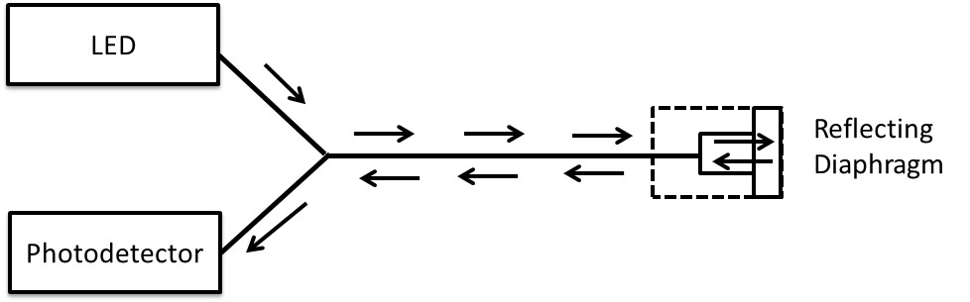
2. Phase Modulated Sensor
Phase Modulated sensors measure change in phase of the light, thereby measuring the cause of the change.
Input light is split into two equal parts; one part travels through reference arm and reaches coupler unaltered while second part of light passes through sensing arm and will get affected by the measureand (ex; temperature, vibration). These two rays interfere inside the coupler. The output across the coupler will vary based on the phase change.
Applications of Optical fiber
- In LAN and other telecommunication.
- Sensor applications
- Medical applications: OCT, Blood analysers
- Computer applications where high speed data transfer is required.
- Remote sensing
- High accuracy gyroscopes
- Security systems

